Project Report


Data Ware House Project

Name: Shahid Ullah
Roll No.: 22I-2019
Dept.: Data Science
Section: DS-A

Table of Contents

Topic | Page
Project Overview | 3
Data Warehouse Schema | 3
Mesh-Join Algorithm | 4
Shortcomings of Mesh-Join | 5
What I learned | 5

1. Project Overview
The purpose of this project was to develop a data warehouse for transactional data using the Mesh Join algorithm. The goal was to efficiently move and transform data from a transactional system into a data warehouse for OLAP (Online Analytical Processing) analysis.
This project involved:
- Implementing the Mesh Join algorithm to join transactional data with master tables.
- Designing a data warehouse schema optimized for the provided dataset.
- Writing SQL queries for OLAP-based analysis and summary table creation.
Key achievements:
- Efficient integration of transactional and master data using the Mesh Join algorithm.
- Creation of dimension and fact tables aligned with data warehousing principles.
- Execution of advanced SQL queries to support analytical requirements like roll-ups and aggregations.

2. Data Warehouse Schema
The schema designed for the data warehouse consisted of the following tables:
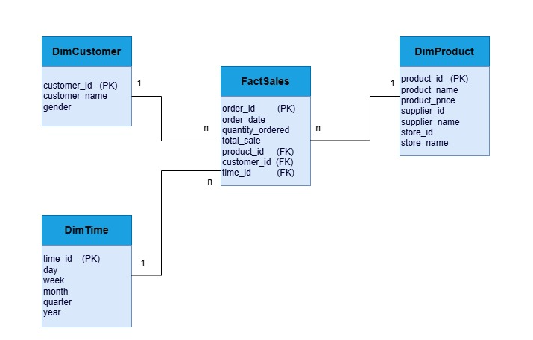
Summary Tables:
The summary tables in the data warehouse were made to store already calculated results to make OLAP queries faster. These tables were useful for different types of analysis, like checking revenue trends, seasonal patterns, supplier contributions, and product relationships. They used ideas like drill-downs, roll-ups, and growth rate calculations to organize the data in a way that made it easier and quicker to use.

3. Mesh Join Algorithm
Def queue ‘q’ which holds partitions of transactional data
Def buffer ‘b’ which holds a subset of transactions
Def lists ‘productData’ and ‘customerData’ which store master data

Partition transactional data into chunks based on partitionSize
Load product and customer data into productData and customerData

Loop until all transactional data is processed:
Read a chunk of transactional data and enqueue it into q
Load transactions from q into buffer b (limit: bufferLimit)

For each transaction in b:
Lookup product details in productData using product_id
Lookup customer details in customerData using customer_id
Enrich transaction with product and customer details
Temporarily store enriched transactions
Write enriched transactions in b to the FactSales table
Remove processed transactions from q
Clear buffer b
4. Shortcomings of Mesh Join
1- In Mesh Join, the partition sizes for stream data and master data need to be the same, whether they are in memory or on disk. This makes it harder to use memory efficiently and can affect how well resources are used during the join.
2- If the master data is much bigger than the transactional data, the Mesh Join algorithm works slower. This happens because every row in the transactional data has to compare with all rows in the master data to find a match, which takes more time and effort.
3- The Mesh Join algorithm doesn’t consider that some products are sold more often than others. Because of this, the join operations are not evenly spread, and this can cause the join process to work less efficiently.

5. What I learned
1) How to connect Java with SQL.
2) How to write SQL queries in Java to get data from Workbench.
3) How to write SQL queries in Java to send data to Workbench.
4) How to implement Mesh Join, including:
a. Dividing database and master data into parts and selecting the next part step by step.
b. Using Hash-Map to hash each data row and saving their locations in a Queue.
c. Joining master data with database data, sending the results to the Data Warehouse, removing those rows from the Hash-Map, and clearing the Queue.
5) Learning new SQL queries for Data Warehouse like rollup and understanding what they do.
6) How to analyze data in the Data Warehouse.

